RF and Microwave Design with JavaScript

Jerry Wiltz

Copyright © 2019 Jerry Wiltz

All rights reserved.

ISBN:

ISBN-13:

DEDICATION

For Marian, my Lúthien.

CONTENTS

|  |  |  |
| --- | --- | --- |
|  | Acknowledgments | i |
|  | Introduction |  |
| 1 | DC and Resistors | 1 |
| 2 | AC and Resistors, Inductors and Capacitors | Pg # |
| 3 | Chapter Name | Pg # |
| 4 | Chapter Name | Pg # |
| 5 | Chapter Name | Pg # |
| 6 | Chapter Name | Pg # |
| 7 | Chapter Name | Pg # |
| 8 | Chapter Name | Pg # |
| 9 | Chapter Name | Pg # |
| 10 | Chapter Name | Pg # |

ACKNOWLEDGMENTS

None.

1 DC and Resistors

This chapter begins with a review of DC theory and resistors. It reviews determining the total resistance of resistors in series: Rseries = R1 + R2 + R3 + …, it reviews determining the total resistance of resistors in parallel 1/Rparallel = 1/R1 + 1/R2 + 1/R3 + ... , and it reviews circuit analysis using voltage dividers. At this point, the arithmetic is straightforward. We will use all this review material to determine the resistance of a more complicated resistor network. So far, we are building on top what of the review material. Along the way, we review maximum power transfer, which is really the point of the whole thing.

All through this chapter, we will repeatedly analyze a resistor 3db attenuator 4 ways - all using DC theory. We do this to gain insight into network theory that is transferable to AC analysis. We will see that we can introduce the s-parameters at DC where the mathematics is much simpler and will set the stage to understand the s-parameters at AC with resistors, inductors, and capacitors covered in chapter 2.

We will analyze the 3dB attenuator using voltage dividers, using Kirchhoff’s Voltage Law, using Matrices, and finally using **nPort** all the while getting the same result. We perform hand calculations first to understand the theory better. After that, we see how simple it is to use **nPort** to accomplish the same thing. So we analyze by hand for learning and getting insight into circuit performance in order to use software, like **nPort**, knowing what to expect in advance.

**DC Review**

We start off with a basic circuit. This is the simplest circuit I can think of. It is shown in figure 1-1. It has a 1 volt DC source and a 1 Ohm resistor load. Note the current convention, current flows out of positive terminals of the source and moves in a clockwise direction.

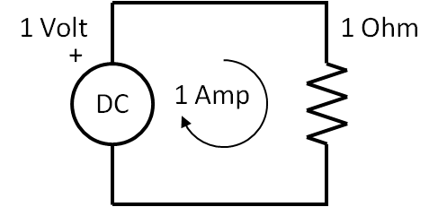

Figure 1-1 The Simplest Circuit

The current is 1 Amp from the equation. This is the **Ohm’s Law** equation.

|  |  |  |
| --- | --- | --- |
|  | $$I=\frac{V}{R}$$ | (1-1) |

For the values of V and R this this equation is very simple to solve as you mentally plug in 1 Volt over 1 Ohm to get 1 Amp.

Suppose there are two or more resistors are in series as shown in figure 1-2. We add them to determine Rseries

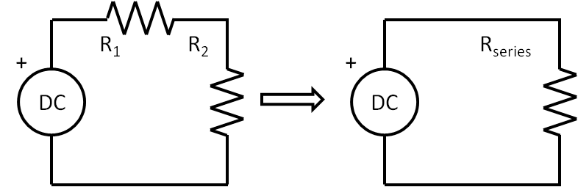

Figure 1-2 Resistors in series

The equation for the total resistance is the sum of all the resistors, and this is shown in equation 1-2.

|  |  |  |
| --- | --- | --- |
|  | $$R_{series}= R_{1}+ R_{2}$$ | (1-2) |

Likewise, if there are 2 or more resistors in parallel, as shown in figure 1-3, Rparallel now is inverse of the sum of the inverse of each resistor and is given by,

|  |  |  |
| --- | --- | --- |
|  | $$R_{parallel}= \frac{1}{\frac{1}{R_{1}}+\frac{1}{R_{2}}}$$ | (1-3) |

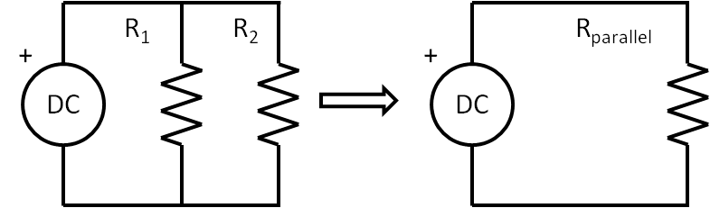

Figure 1-3 Resistors in parallel

Now we can determine the total resistance of a more complicated resistor network. A great many configurations of resistors can be combined into a single resistor by combining resistors that are in parallel and then adding to resistors in series. Keep doing this until there is one resistor left that is equivalent to the original network resistance, Requivalent. Take a look at the circuit shown in figure 1-4. You should work this out by hand to get insight and experience. You should work through them by hand at first.

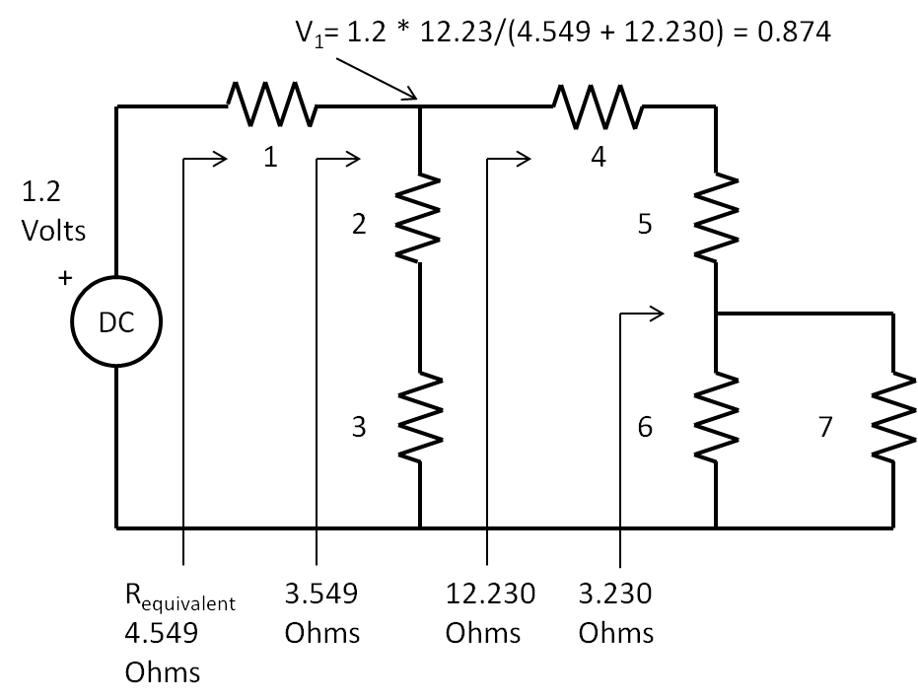

Figure 1-4 Finding the equivalent single resistor from seven resistors

Starting from the far right of figure 1-4, here are some steps to take:

* Parallel combine the resistors 6 Ω and 7 Ω together for 3.23 Ω
* Add that combination to the series resistors of 4 Ω and 5 Ω for 12.23 Ω
* Parallel combine that with the sum 2 Ω and 3 Ω for 3.549 Ω
* Add that to the 1 Ω for 4.549 Ω

I have included equivalent resistor values in figure 1-4, you should get those same results. Here is the result of an equation written on one line that does everything, Requivalent is 4.55 Ohms.

|  |  |  |
| --- | --- | --- |
|  | $$4.549=1+1/(1/(4+5+1/(1/6+1/7))+1/(2+3))$$ | (1-4) |

Look at this equation and map the resistor values to the figure. You can see the parallel combination of the 6 and 7 Ohm resistors, then summing that with the 4 and 5 Ohm resistors, then putting that in parallel with the two series resistors of 2 and 3 Ohms, and finally adding that result with the series 1 Ohm resistor. Open up a browser such as Chrome. Then copy and paste the following into the search field: 1 + 1/( 1/(4 + 5+ 1/(1/6+1/7)) + 1/(2 + 3)). This wakes up the calculator that is part of the browser and boom, there is the result of 4.5591 Ohms. Pretty cool.

**Maximum Power Transfer**

Now we introduce the concept of Maximum Power Transfer from a source to a load. In the circuit shown in figure 1-5, the source is located inside the dotted line box that also contains a series resistor that is the internal resistance of the source. The load is connected across the terminals of the dotted line box. The load resistance value can be varied, say to a value lower than the internal resistor, or a higher value, or equal to the internal resistor value. We show these values in the table also in figure 1-6. This table has “educated guesses” for the load resistance and power is maximized when the load resistance is equal to the source resistance. So maximum power transfer occurs when **RSource = RLoad**. In the real world, there will always be a source resistance, no matter what, and power from the source will always be wasted and dissipated inside its own internal resistance. For now at DC, we define the value of the internal resistor to 50 Ohms. Power in an electrical circuit is the product of the voltage across a resistor and current flow through it. So for any resistor value, the power in Watts dissipated by it is,

|  |  |  |
| --- | --- | --- |
|  | $$P=V*I$$ | (1-5) |

As was mentioned, in the table of figure 1-5, there are some “educated guesses” of values of the load resistor, RLoad. The columns in the table show the value of load resistor and corresponding total current, the voltage across the load resistor and the power, in Watts, transferred to the load. The key observation that maximum power transfer occurs when the source resistance equals the load resistance. Notice the PLoad is greatest at RLoad = 50 Ohms and less than that if the RLoad is either less than or greater than 50 Ohms. Note also, if the source resistance is 50 Ohms, the load resistance must be 50 Ohms. Maximum power transfer is a fundamental concept in RF and microwave design.

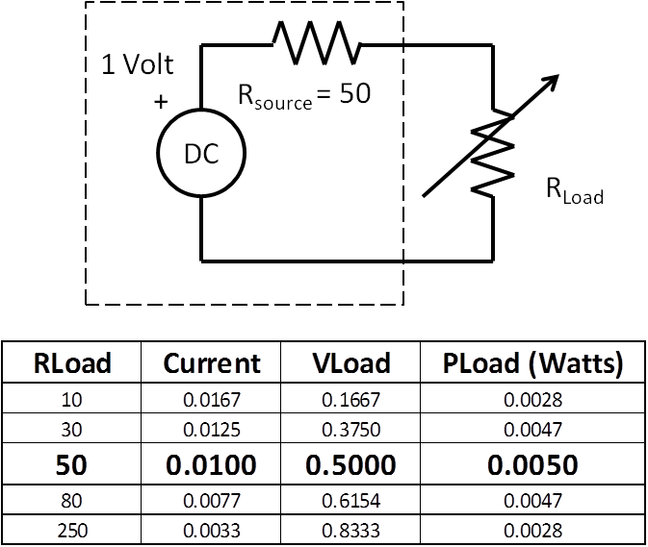

Figure 1-5 Maximum Power Transfer demo with “educated guesses” of load resistor values

Now we introduce the Through 2-port as shown in figure 1-6. Electrically, it is no different than the maximum power transfer circuit shown in figure 1-5. The circuit shown in figure 1-6 is a simple modification of figure 1-5. In this case, the Through 2-Port was inserted between the source and the load. The Through 2-port has four terminals, two terminals for each port. So for circuit with n number of ports, it has 2n terminals. With the Through 2-port in place, maximum power is transferred. As we proceed in this and the next chapters, we will replace the Through 2-port with more complicated 2-ports

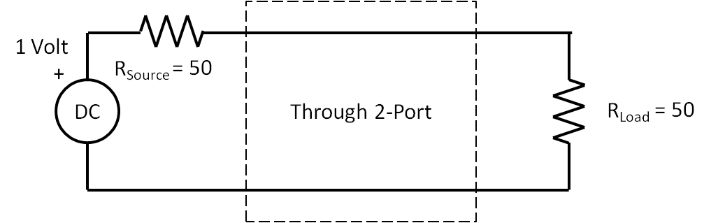

Figure 1-6 Showing the very simple Through 2-port, Power transfer is maximized.

What is the voltage at the load resistor in the circuit of figure 1-6? It is 0.5 Volts, right? Since the resistors are equal and in series, the same current flow through them and therefore they each have same voltage spread across them. There is a simple equation for this. This is the voltage divider equation.

|  |  |  |
| --- | --- | --- |
|  | $$V_{Load}=V_{Source}*\frac{R_{Load}}{R_{Source}+R_{Load}}=1*\frac{50}{100}=0.5V$$ | (1-6) |

**The Decibel**

Historically, back in the days of the early telephone, and due to the large range of the ratios of power gains and losses of telephone transmission lines and systems, it became more practical to plot on paper these ratios with log scales. In honor of Alexander Graham Bell, the unit for this log of ratios was named the ***bel.*** To make the plotting even easier the ***bel*** was multiplied by 10 to give the new unit, the ***decibel.*** A decibel is defined as one tenth of a bel. That’s why we multiply by 10. Now why did we multiply by 20 in equation 1-11 instead of 10? The decibel is 10 * log of a power ratio. But the ratio in equation 1-11 is a voltage ratio. Since these are voltages across resistors, we need to obtain the power dissipated by the resistors. Since,

|  |  |  |
| --- | --- | --- |
|  | $$I=\frac{V}{R}$$ | (1-7) |

and,

|  |  |  |
| --- | --- | --- |
|  | $$P=V*I$$ | (1-8) |

therefore,

|  |  |  |
| --- | --- | --- |
|  | $$P=V*\frac{V}{R}=\frac{V^{2}}{R} Watts$$ | (1-9) |

Notice that V squared in the numerator, taking the log of a number raised to a power, the power multiplies the log of the base.

|  |  |  |
| --- | --- | --- |
|  | $$10*\log\left({4.52}^{2}\right)=2*10*\log\left(4.5\right)= 20*\log\left(4.5\right)$$ | (1-10) |

So just remember, when dealing with voltages, use 20*log, when dealing with powers, use 10*log. For far more info check the wiki page on the [decibel](https://en.wikipedia.org/wiki/Decibel).

If you think of an RF system as blocks chained together and each blocks has either a gain or a loss, then you could determine the overall gain or loss by multiplying all the individual stages together. But that is really messy. Much easier to use dB’s because we add them rather than multiply them, the log of multiplied numbers is equal to the addition of the log of each stage. Suppose there is a very simple RF system that has two blocks. The first block is an amplifier with a gain of 177. The second block is long cable that has a loss of 0.707. The overall gain is 177 times 0.707 = 125. But look,

|  |  |  |
| --- | --- | --- |
|  | $$20\log\left(177*0.707\right)=20\log\left(177\right)+20log⁡(0.707)$$ | (1-11) |

Or

|  |  |  |
| --- | --- | --- |
|  | $$42dB=45dB-3dB$$ | (1-12) |

Suppose there are dozens of blocks to make up an RF system. It is much easier thinking in dB’s and adding than thinking of multiplying huge or tiny number together.

One of the things seasoned RF types could do is dB arithmetic in their heads. It takes a little memorization and practice and the memorization part is knowing the logs of x=1 through x=10 by heart shown in the table below.

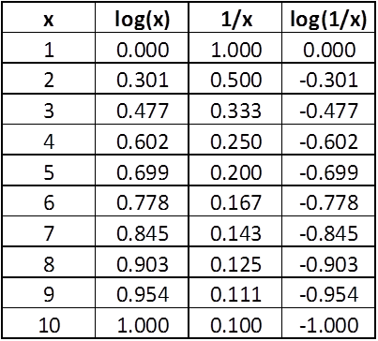

So let’s redo the amplifier gain of 177 and cable loss of 0.707, quickly and approximately in our head, assuming we have memorized and practiced. For the amplifier gain, 177 is 1.77 * 100, so using the memorized table 1.77 is close to 2 and the log of 2 is close to 0.3; the log of 100 is 2, so we add the logs 0.3 to 2 to get 2.3 and then multiply by 20 to get 46 dB gain for the amplifier. Similarly for the cable loss, 0.707 is 7 * 1/10, so the log of 7 is about 0.8 and the log of 1/10 is -1.0, obtaining the sum of 0.8 - 1.0 to get -0.2 and multiply by 20 to get -4 dB loss for the cable. Lastly, to obtain the overall gain of this RF system we add 46 dB to - 4 dB to get 42 dB. It is the same result as in equation (1-17). So, by expressing large or small numbers as a number between 1 and 10 with multiples of  10 or 1/10, (This is called scientific notation) using logs we can reduce long chains of multiplication to simpler chains of addition. The decibel is used all over the place in RF and Microwave.

**The 3dB Attenuator**

Figure 1-7 shows the schematic of a 3dB attenuator that we will analyze by the voltage divider method by hand, and then by Kirchhoff’s Voltage Law using JavaScript only, and then by Kirchhoff’s Voltage Law using **nPort** matrix methods, and lastly by using **nPort**’s-parameter methods.

**The 3dB Attenuator solution #1 of 4:**

**The voltage divider method**

One of goals of this chapter is to analyze this circuit for attenuation by hand and then by JavaScript. Additionally, spending time with the hand analysis is vital because that is what will train you to understand what is happening. It’s like learning to cook, you have to cook and experience the way food comes together, only then can you create brand new dishes. Similarly, you have to experience how the equations work, only then can create brand new circuits. Moreover, working through things by hand at first will give you insight and will give you a notion of what to expect rather than blindly using computers and software while being unaware of what to do next when you don’t get expected results. So we will begin, first, to analyze the 3dB attenuator circuit shown in figure 1-7.

We start the hand analysis of the 3dB attenuator by using the voltage divider technique. The voltage divider formula is shown in equation 1-6.

* Combine R1, R2, R3, and RLoad into one resistor, RV1.
* Plug V=1, RSource and RV1 into the voltage divider equation 1.6 and find V1
* Combine R3 and RLoad into one resistor, RV2
* Plug V1, R2, and RV2 into the voltage divider equation 1-6 and find V2
* Take 20*log(V2/V1) to compute the attenuation of 3dB.

With these steps in mind, let us find the interior voltages V1 and V2 and the attenuation of the 3dB attenuator shown in figure 1-7.

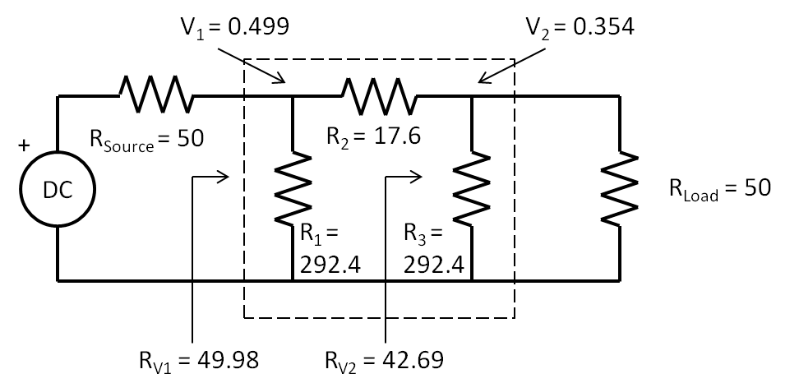

Figure 1-7 Schematic of a 3 dB Attenuator between a source and load

First, find RV1 given R1,R2,R3, and RLoad using the techniques of the resistance of a complicated circuit such that of figure 1.4.

|  |  |  |
| --- | --- | --- |
|  | $$R_{V1}=\frac{1}{\frac{1}{292.4}+\frac{1}{17.6+\frac{1}{\frac{1}{292.4}+\frac{1}{50}}}}=49.98Ω$$ | (1-13) |

Second, now we use the voltage divider equation to find V1

|  |  |  |
| --- | --- | --- |
|  |  | (1-14) |

Third, find RV2 by finding parallel resistance of R3 and RLoad

|  |  |  |
| --- | --- | --- |
|  |  | (1-15) |

Fourth, find V2 using the voltage divider equation and V1 along with R2 and RV2

|  |  |  |
| --- | --- | --- |
|  |  | (1-16) |

Lastly, plug in V1 and V2 into equation 1-17 to calculate the attenuation in dB.

|  |  |  |
| --- | --- | --- |
|  | $$20*\log\left(\frac{V_{2}}{V_{1}}\right)=20*\log\left(\frac{0.354}{0.499}\right)=-2.997dB$$ | (1-17) |

You should work through the above analysis by hand, get the same answers for V1,V2, and dB. Next, repeat the analysis, by hand for a 10dB attenuator having values of R1 = R3 = 96.25 Ohms and R2 = 71.15 Ohms. In this new situation, did you notice that V1 did not change? It is still 0.5 Volts. Why?

**The 3dB Attenuator solution #2 of 4:**

**Kirchhoff’s Voltage Law and JavaScript**

If you done the hand calculations thus far, you are realizing how tedious and mistake prone all this arithmetic can be. It would be great to mechanize this into forms that a computer could read and let a program to all the work. Since we are analyzing DC, the tedious analysis is performed only one time. However when we are analyzing AC, the analysis must be performed for each frequency point, so computer solutions are even more important.

So now we begin to form a foundation for the mechanization of these analyses and using computer and software. First, we will introduce Kirchhoff’s Voltage Law identifying and setting up the loop currents and voltage drops across resistors. Second, will introduce the resistor matrix to solve for currents and use JavaScript to do the arithmetic. Third, we will use the currents to solve for the voltages of interest and take their ratios. Lastly, we will express these ratios in dB and get the same result as we did for the voltage divider technique.

Starting with Kirchhoff’s Voltage Law: for a closed loop series path the algebraic sum of all the voltages around any closed loop in a circuit is equal to zero. In figure 1-8, there is one closed current loop and the Kirchhoff’s Voltage Law equation for this situation is

|  |  |  |
| --- | --- | --- |
|  | $$V-I*R=0$$ | (1-18) |

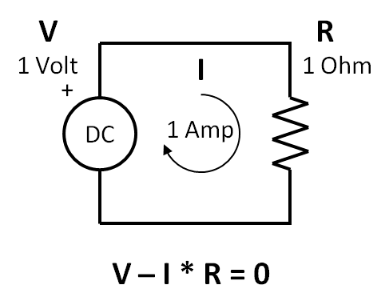

Figure 1-8 Simple schematic showing Kirchhoff’s Voltage Law.

Listing 1.1 below shows JavaScript in the body section of an html page. You should create a file named index.html and camp there until can see the 1 Amp result for the current, I, in the console window. **Make sure you can do all of this before going further.** You should get this listing to run in your browser and see the output in the console of your browser. Now would be a good time to learn you to use some of the console. I use YouTube a lot to learn about these things. So have at it.

Listing 1-1 Simple JavaScript and Kirchhoff’s Voltage Law.

<!DOCTYPE html>

<html>

<head>

<title>Listing 1-1 Kirchhoffs Voltage Law</title>

</head>

<body>

<script>

// Kirchhoff voltage law: The sum of the voltages around a loop is 0 or V - I*R = 0;

// define the resistor and voltage source

var R = 1, V = 1, I = 0;

// solve for I, if V - I*R = 0, then  V = I*R and I = V/R

I = V/R;

// use console.log to display I, and in this case, I = a1

console.log('The loop current is ...');

console.log(I+' Amp');

</script>

</body>

</html>

Do you know how to use the console in your browser now? From now on, I am assuming you know how.

Next, and knowing how to observe JavaScript results on console of the browser, we will analyze the 3 dB attenuator again. Let us apply Kirchhoff’s Voltage Law to the 3 dB Attenuator first shown in figure 1-8. We redraw it in figure 1-10 to show the three current loops and apply Kirchhoff’s Voltage Law three times, one for each loop.

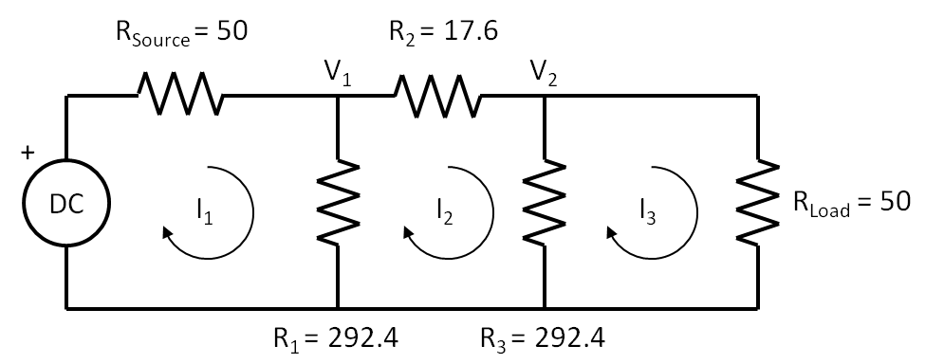

Figure 1-9 3dB Attenuator analysis using Kirchhoff’s Voltage Law

Here is Kirchhoff’s Voltage Law for the first current loop,

|  |  |  |
| --- | --- | --- |
|  | $$V{-I}_{1}*R_{Source}{-I}_{1}*R_{1}+I_{2}*R_{1}+I_{3}*0=0$$ | (1-19) |

Regarding order of operations, multiplication is done first then addition or subtraction is done next. Thus we **do not** perform *V-I1* in equation 1-19. Remember the mechanics here, look at the first current loop, all the voltages have to sum to zero. The sign of the current, I1, is negative, but the sign of I2 is positive, since I2 flows in the opposite direction of I1. I3 is listed for completeness, since there is no common resistor between I1 and I3, I3 has no impact on the first current loop. Also, remember the order of operations, you multiply first, then add. Lastly, note that V will be a known variable, but I1, I2, and I3 are unknown variables. In order to solve for each unknown, we will need three equations containing the three unknowns. Equation 1-19 is the first equation.

Next, apply Kirchhoff’s Voltage Law to the second current loop,

|  |  |  |
| --- | --- | --- |
|  | $$0{+I}_{1}*R_{1}{-I}_{2}*R_{1}-I_{2}*R_{2}-I_{2}*R_{3}-I_{3}*R_{2}=0$$ | (1-20) |

Next, apply Kirchhoff’s Voltage Law to the third current loop,

|  |  |  |
| --- | --- | --- |
|  | $$0{+I}_{1}*0+I_{2}*R_{3}-I_{3}*R_{3}-I_{3}*R_{Load}=0$$ | (1-21) |

So the three equations, 1-19, 1-20, and 1-21 of Kirchhoff’s Law:  
V-I*R=0. The next step is to put them into the form of:  
V=R*I, and we use algebra for this. I put the results all together in equation 1-22 below.

|  |  |  |
| --- | --- | --- |
|  | $$\begin{matrix}V= & \left(R_{Source}+R_{1}\right)*I_{1} & {-R}_{1}*I_{2} & 0*I_{3} \\ 0= & {-R}_{1}*I_{1} & {(R}_{1}+R_{2}+R_{3})*I_{2} & {-R}_{3}*I_{3} \\ 0= & 0*I_{1} & {-R}_{3}*I_{2} & \left(R_{3}+R_{Load}\right)*I_{3}\end{matrix}$$ | (1-22) |

Look at the first line of equation 1-22. There are 2 resistors that carry I1: RSource and R1 and there is an adjacent current loop carrying I2 through the common resistor, R1. Note again, I2 is flowing opposite I1 and the actual current through R1 is I1-I2. Also notice that each equation must contain terms that have all three currents. I1 and I2 matter in the first line of equation 1-22, but not I3 since the first and third loops do not touch. In the second line in equation 1-22, all the currents matter since loop2 is adjacent to loops 1 and 3.

So finally, let's put equations 1-22 in matrix form of **V = R * I** and the result is shown in equation 1-23.

|  |  |  |
| --- | --- | --- |
|  | $$\left[\begin{matrix}V \\ 0 \\ 0\end{matrix}\right]=\left[\begin{matrix}R_{Source}+R_{1} & -R_{1} & 0 \\ -R_{1} & R_{1}+R_{2}+R_{3} & -R_{3} \\ 0 & -R_{3} & R_{3}+R_{Load}\end{matrix}\right]*\left[\begin{matrix}I_{1} \\ I_{2} \\ I_{3}\end{matrix}\right]$$ | (1-23) |

It is important to compare equations 1-22 to 1-23. See the currents shown in equation 1-22 map over to the currents shown in equation 1-23. Regarding terminology, on the far left of the equation is the 3 by 1 Voltage Matrix. On the far right of the equation is the 3 by 1 Current matrix. In the center of the equation is the 3 by 3 Resistor Matrix. So this say that the voltage matrix is equal to the resistor matrix multiplied by the current matrix. Examine the R matrix shown by itself in equation 1-24. The resistors are positive along the diagonal. This is always the case. Also note all the other resistors are negative, again this is always the case. Common resistors are always negative and are symmetrical about the diagonal. This always the case as well. Since the R matrix is so predictable, it can be formed by inspection. This is important. No need for all the equations and algebra and all the rest. Follow the rules to form the R matrix, then stick the voltages on the left, and the currents on the right and you have it.

|  |  |  |
| --- | --- | --- |
|  | $$R=\left[\begin{matrix}R_{Source}+R_{1} & -R_{1} & 0 \\ -R_{1} & R_{1}+R_{2}+R_{3} & -R_{3} \\ 0 & -R_{3} & R_{3}+R_{Load}\end{matrix}\right]$$ | (1-24) |

Now all we have to do is to solve for I, given V and R.

Referring to the 3dB attenuator shown in figure 1-9, the reason we need to know the currents I1, I2, and I3 is to find the voltages V1 and V2 which are across R1 and R3 respectively. Here are the equations for V1 and for V2,

|  |  |  |
| --- | --- | --- |
|  |  | (1-25) |

|  |  |  |
| --- | --- | --- |
|  |  | (1-26) |

Solving matrices by hand is tedious and error prone. I always make a little mistake, no matter how careful I am. Then I have to go back and find it and fix it. It is much better to have the computer do it. But we will cover the basic theory first. We will use **Cramer’s Rule** and JavaScript to solve for I1, I2, and I3. If unfamiliar with Cramer’s Rule, you can look it up on YouTube and find out more about it. So here is Cramer’s Rule for the solution for I1,

|  |  |  |
| --- | --- | --- |
|  |  | (1-27) |

So all we have to do is solve for the determinant of the numerator and divide it by the determinant of the denominator. There is a simple formula to obtain the determinant of a 3 by 3 matrix, given the matrix, A, in equation 1-27,

|  |  |  |
| --- | --- | --- |
|  | $$A=\left[\begin{matrix}a_{11} & a_{12} & a_{13} \\ a_{21} & a_{22} & a_{23} \\ a_{31} & a_{32} & a_{33}\end{matrix}\right]$$ | (1-28) |

For the R matrix, RSource + R1 = a11. Make sure you understand that. The determinant of matrix A is given by the formula in equation 1-28. Yes, this looks awful, but JavaScript will be used to solve the currents.

|  |  |  |
| --- | --- | --- |
|  | $$Determinant of A =a_{11}*a_{22}*a_{33}+a_{12}*a_{23}*a_{31}+a_{13}*a_{21}*a_{32}-a_{31}*a_{22}*a_{13}-a_{32}*a_{23}*a_{11}-a_{33}*a_{21}*a_{12}$$ | (1-29) |

We follow the same procedure for I2 and I3, or

|  |  |  |
| --- | --- | --- |
|  |  | (1-30) |

|  |  |  |
| --- | --- | --- |
|  |  | (1-31) |

We calculate the currents and then use equations 1-25 and 1-26 to find V1 and V2. Lastly we calculate 20log(V2/V1) for the attenuation, in dB.

In the listing 1.2, all the formulas for current have the same denominator, D and is solved once and used three times. The three numerators are different and are named, I1D, I2D, and I3D. So each current is I1=I1D/D, I2=I2D/D, and I3=I3D/D. Once I1, I2, and I2 are known, then V1 and V2 can be determined and the 20log(V2/V1) is calculated.

Let’s solve for I1 using equations 1-26 and 1-28. We set V equal to one volt, and plug in the values of the resistors in the 3dB attenuator as shown back in figure 1-10.

|  |  |  |
| --- | --- | --- |
|  | $$I_{1}=\frac{\left[\begin{matrix}1 & -292.4 & 0 \\ 0 & 602.4 & -292.4 \\ 0 & -292.4 & 100\end{matrix}\right]}{\left[\begin{matrix}100 & -292.4 & 0 \\ -292.4 & 602.4 & -292.4 \\ 0 & -292.4 & 100\end{matrix}\right]}=\frac{120764}{70624026}=0.0017A$$ | (1-32) |

So I1 = 0.0017 Amps. Listing 1.2 calculates the three currents and the two voltages and then computes the attenuation.

Listing 1.2 JavaScript listing.

<!DOCTYPE html>

<html>

<head>

<title>Listing 1-2 Cramers Rule</title>

</head>

<body>

<script>

// define the resistors

var Rsource = 50, R1 = 292.4, R2 = 17.6, R3 = 292.4, Rload = 50;

// define the denominator, D which is the determinant of the resistor matrix using the 3x3 short cut method

var D = +(Rsource+R1)*(R1+R2+R3)*(R3+Rload) +0 +0 -0 -(-R1)*(-R1)*(Rsource+R1) -(R3+Rload)*(-R1)*(R1);

//find I1D, the numerator, I1D which is the determinant of the modified resistor matrix

var I1D = +(1)*(R1+R2+R3)*(R3+Rload) +0 +0 -0 -(-R3)*(-R3)*(1) -0;

var I1 = I1D/D;

var I2D = +0 +0 +0 -0 -0 -(R3+Rload)*(-R1)*(1);

var I2 = I2D/D;

var I3D = +0 + 0 +(1)*(-R1)*(-R3) -0 -0 -0;

var I3 = I3D/D;

// find V1 = R1*(I1-I2)

var V1 = R1*(I1 - I2);

// find V2 = R3*(I2-I3)

var V2 = R3*(I2 - I3);

// find the attenuation by 20 * log10 (V2/V1)

var attn = 20*Math.log10(V2/V1);

console.log('The attenuation is ...');

console.log(attn + ' dB');

</script>

</body>

</html>

**The 3dB Attenuator solution #3 of 4:**

**Kirchhoff’s Voltage Law and nPort Matrix Methods**

So for, we have analyzed the 3 dB attenuator two ways, the voltage divider technique and with Kirchhoff’s Voltage Law. The first way was a hand analysis with voltage dividers, the second way was a matrix analysis. Neither of these techniques required **nPort**. So now we introduce a third way by using **nPort** matrix functions. For very large circuits with a great loops, the matrices are too large for cramer’s rule and determinants. Large matrices can only be solved with computers with matrix methods. Equation 1-23 shown again equation 1-28 is

|  |  |  |
| --- | --- | --- |
|  | $$\left[\begin{matrix}V \\ 0 \\ 0\end{matrix}\right]=\left[\begin{matrix}R_{Source}+R_{1} & -R_{1} & 0 \\ -R_{1} & R_{1}+R_{2}+R_{3} & -R_{3} \\ 0 & -R_{3} & R_{3}+R_{Load}\end{matrix}\right]*\left[\begin{matrix}I_{1} \\ I_{2} \\ I_{3}\end{matrix}\right]$$ | (1-33) |

The general form of this matrix is,

|  |  |  |
| --- | --- | --- |
|  | $$\left[V\right]=\left[R\right]*\left[I\right]$$ | (1-34) |

Solving for [I],

|  |  |  |
| --- | --- | --- |
|  | $$\left[I\right]=\frac{\left[V\right]}{\left[R\right]}=\left[V\right]*{\left[R\right]}^{-1}$$ | (1-35) |

Where [R]-1 is called the **inverse** of [R]. Once we have[R]-1, all we have to do to calculate the current is to multiply the voltage matrix, [V] by [R]-1 to obtain the currents. In this next listing, **nPort** will be used to solve perform matrix operations. First, we define the [R] matrix. Second, we define the [V] matrix. Third, We produce, [R]-1 with the **nP.invert()** method. Fourth, we obtain the [I] matrix by multiplying the inverted [R] matrix by the [V] matrix in the matrix **nP.mul()** method. All of these steps are shown in listing 1.3. Create listing 1.3 named index.js and run it. Examine the object, i, with the console and see what object members and methods are. In an nP.matrix object, there is only one member and its key name is “m” and its data is a JavaScript array of arrays. Each row of the matrix is an array.

Listing 1.3 using nPort matrix methods.

<!DOCTYPE html>

<html>

<head>

<title>Listing 1.3 nPort Matrix Invert</title>

</head>

<body>

<script src="nP.js"></script>

<script>

// define the resistors

var Rsource = 50, R1 = 292.4, R2 = 17.6, R3 = 292.4, Rload = 50;

// define the resistor matrix

var r = nP.matrix( [

[Rsource + R1, -R1         , 0 ],

[-R1         , R1 + R2 + R3, -R3       ],

[0           , -R3 , R3 + Rload],

] );

// define the voltage generator matrix

var v = nP.matrix( [

[1],

[0],

[0],

] );

// find the inverse of the resistor matrix

var rInvert = r.invert();

// find the current matrix by multiplying rInvert by the voltage matrix

var i = rInvert.mul(v);

// find V1 = R1*(I1-I2)

var V1 = R1*(i.m[0] - i.m[1]);

// find V2 = R3*(I2-I3)

var V2 = R3*(i.m[1] - i.m[2]);

// find the attenuation by 20 * log10 (V2/V1)

var attn = 20*Math.log10(V2/V1);

console.log('The attenuation is ...');

console.log(attn + ' dB');

</script>

</body>

</html

**Basketball and the Scattering Parameters**

For those who have never heard of s-parameters and are new to RF, here is a basketball analogy for RF transmission and s-parameters. According to this analogy, the basketball is the input voltage and the rim is the RF circuit. Also, according to this analogy, we consider only three cases. The best shots don’t touch the rim and go through, this is case 1. Uglier shots touch the rim and go through, this is case 2. Missed shots bounce off the rim and don’t go through, this is case 3.

If the ball goes through the rim as in case 1, we could say that is was **transmitted** through the hoop. If the ball touches the rim as in case 2, we could say that it was also transmitted, but has lost some energy. If the ball misses in case 3, we could say that it was **reflected** back off the hoop.

In case 1, there is complete transmission and no reflection. In case 2, there is mostly transmission with some reflection. In case 3, there is no transmission and complete reflection.

Consider case 2: There is a range a shots from less touching the rim to greater touching the rim. At the high end of the range, there is greater transmission and lesser reflection. At the low end of the ranger, there is lesser transmission and greater reflection.

How do we represent these situations of the basketball? This will really sound strange, but this is what happens in the RF world. It is not called black magic for nothing. At the high end of the range, we could say that the basketball became a little smaller as it was transmitted, and say a new ping-pong ball is reflected back at the shooter. At the low end of the range, we could say that basketball became much smaller as it was transmitted, and that say a new baseball was reflected back to the shooter. As the transmitted basketball becomes smaller, the reflected ball gets bigger.

Now we name transmission and reflection coefficients as **τ**, “tau” and **ρ**, “rho” respectively, and define the range of their values from 0 to 1. Moreover, they are related to each other as τ goes up ρ goes down, if τ is 1 ρ is 0 and vice versa**.** Here are our three cases again:

* In case 1, if τ = 1, then ρ = 0.
* In case 2, if τ is near 1, then ρ is near 0. If τ is near 0, then ρ is near 1.
* In case 3, if τ = 0, then ρ = 1.

All actual RF circuits operate in case 2. In development, the RF designer must maximize transmission and minimize reflection; or saying it another way maximize tau and minimize rho.

Now we introduce the s-parameters. Again, we will do this at DC because the math is much easier and when we transition to AC, we will have a better feel for what is going on. Figure 1-10a shows the 3dB attenuator. Figure 1-10b shows the same circuit but relabeled to conform to the definitions of the s-parameters. The electrical performance is the same for both schematics.

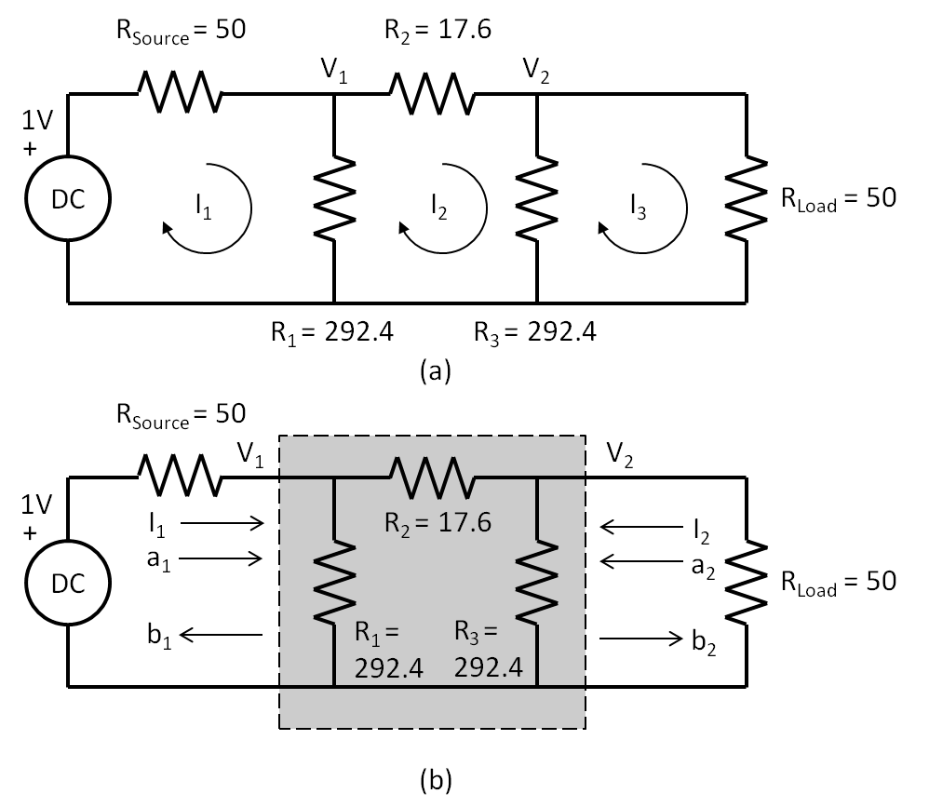

Figure 1-10 3dB Attenuator being analyzed as a 2-port

Some comments regarding figure 1-10. First, V1, V2, and I1 are the same for (a) and (b). Second, we do not know what is inside the shaded area in (b). Third, all we need to know are the currents and voltages at each port when terminated with RSource and RLoad. Fourth, I2 in (b) is the negative of I3 in (a). This is required because s-parameters are defined by current flow into a port. Fifth, we have introduced new variables **a** and **b** at each port. As we will see in a moment, **a** and **b** are related to V and I at each port. For s-parameters the input to a port is a, and the output of a port is b. This is shown by the arrows for them in figure 1-10b. Back to the basketball analogy, a is the shot that goes through and b is the ping pong ball that comes back.

|  |  |  |
| --- | --- | --- |
|  | $$s_{11}=\frac{b_{1}}{a_{1}}=rho$$ | (1-36) |

|  |  |  |
| --- | --- | --- |
|  |  | (1-37) |

But what is a1 and b1? They are related to V1 and I1 buy the following,

|  |  |  |
| --- | --- | --- |
|  | $$a_{1}=\frac{V_{1}+I_{1}*50}{2\sqrt{50}}; b_{1}=\frac{V_{1}-I_{1}*50}{2\sqrt{50}}; b_{2}=\frac{V_{2}-I_{2}*50}{2\sqrt{50}}$$ | (1-38) |

What are the units for a1, b1, and b2? You can see that the units for the numerators in equation 1-38 are in Volts. Also, you can see that the denominators are in square root Ohms. This is shown below in equation 1-39. But now square a1 and now the units become watts per equation 1-9.

|  |  |  |
| --- | --- | --- |
|  | $$a_{1} =\frac{V}{\sqrt{Ω}} ; {a_{1}}^{2}= \frac{V^{2}}{Ω} Watts$$ | (1-39) |

For this reason, a and b waves are referred to in the literature as power waves.

2 CHAPTER NAME

Insert chapter two text here. Insert chapter two text here. Insert chapter two text here. Insert chapter two text here. Insert chapter two text here. Insert chapter two text here. Insert chapter two text here. Insert chapter two text here. Insert chapter two text here. Insert chapter two text here. Insert chapter two text here. Insert chapter two text here. Insert chapter two text here.

Insert chapter two text here. Insert chapter two text here. Insert chapter two text here. Insert chapter two text here. Insert chapter two text here. Insert chapter two text here. Insert chapter two text here. Insert chapter two text here. Insert chapter two text here. Insert chapter two text here. Insert chapter two text here. Insert chapter two text here. Insert chapter two text here. Insert chapter two text here. Insert chapter two text here. Insert chapter two text here. Insert chapter two text here. Insert chapter two text here. Insert chapter two text here. Insert chapter two text here. Insert chapter two text here. Insert chapter two text here. Insert chapter two text here. Insert chapter two text here. Insert chapter two text here. Insert chapter two text here. Insert chapter two text here. Insert chapter two text here. Insert chapter two text here. Insert chapter two text here. Insert chapter two text here.

Insert chapter two text here. Insert chapter two text here. Insert chapter two text here. Insert chapter two text here. Insert chapter two text here. Insert chapter two text here. Insert chapter two text here. Insert chapter two text here. Insert chapter two text here. Insert chapter two text here. Insert chapter two text here. Insert chapter two text here. Insert chapter two text here. Insert chapter two text here. Insert chapter two text here. Insert chapter two text here. Insert chapter two text here. Insert chapter two text here.

Insert chapter two text here. Insert chapter two text here. Insert chapter two text here. Insert chapter two text here. Insert chapter two text here. Insert chapter two text here. Insert chapter two text here. Insert chapter two text here. Insert chapter two text here. Insert chapter two text here. Insert chapter two text here. Insert chapter two text here. Insert chapter two text here. Insert chapter two text here. Insert chapter two text here. Insert chapter two text here. Insert chapter two text here. Insert chapter two text here.

Insert chapter two text here. Insert chapter two text here. Insert chapter two text here. Insert chapter two text here. Insert chapter two text here. Insert chapter two text here. Insert chapter two text here. Insert chapter two text here. Insert chapter two text here. Insert chapter two text here. Insert chapter two text here.

Insert chapter two text here. Insert chapter two text here. Insert chapter two text here. Insert chapter two text here. Insert chapter two text here. Insert chapter two text here. Insert chapter two text here. Insert chapter two text here. Insert chapter two text here. Insert chapter two text here. Insert chapter two text here. Insert chapter two text here. Insert chapter two text here. Insert chapter two text here. Insert chapter two text here.

Insert chapter two text here. Insert chapter two text here. Insert chapter two text here. Insert chapter two text here. Insert chapter two text here. Insert chapter two text here. Insert chapter two text here. Insert chapter two text here. Insert chapter two text here. Insert chapter two text here. Insert chapter two text here. Insert chapter two text here. Insert chapter two text here. Insert chapter two text here. Insert chapter two text here. Insert chapter two text here. Insert chapter two text here. Insert chapter two text here. Insert chapter two text here. Insert chapter two text here. Insert chapter two text here. Insert chapter two text here. Insert chapter two text here.

Insert chapter two text here. Insert chapter two text here. Insert chapter two text here. Insert chapter two text here. Insert chapter two text here. Insert chapter two text here. Insert chapter two text here. Insert chapter two text here. Insert chapter two text here. Insert chapter two text here. Insert chapter two text here. Insert chapter two text here. Insert chapter two text here. Insert chapter two text here. Insert chapter two text here. Insert chapter two text here. Insert chapter two text here. Insert chapter two text here.

3 CHAPTER NAME

Insert chapter three text here. Insert chapter three text here. Insert chapter three text here. Insert chapter three text here. Insert chapter three text here. Insert chapter three text here. Insert chapter three text here. Insert chapter three text here. Insert chapter three text here. Insert chapter three text here. Insert chapter three text here. Insert chapter three text here.

Insert chapter three text here. Insert chapter three text here. Insert chapter three text here. Insert chapter three text here. Insert chapter three text here. Insert chapter three text here. Insert chapter three text here. Insert chapter three text here. Insert chapter three text here. Insert chapter three text here. Insert chapter three text here. Insert chapter three text here.

Insert chapter three text here. Insert chapter three text here. Insert chapter three text here. Insert chapter three text here. Insert chapter three text here. Insert chapter three text here. Insert chapter three text here. Insert chapter three text here. Insert chapter three text here. Insert chapter three text here. Insert chapter three text here. Insert chapter three text here. Insert chapter three text here. Insert chapter three text here. Insert chapter three text here. Insert chapter three text here. Insert chapter three text here. Insert chapter three text here. Insert chapter three text here. Insert chapter three text here. Insert chapter three text here. Insert chapter three text here. Insert chapter three text here. Insert chapter three text here. Insert chapter three text here. Insert chapter three text here. Insert chapter three text here. Insert chapter three text here. Insert chapter three text here. Insert chapter three text here. Insert chapter three text here. Insert chapter three text here. Insert chapter three text here. Insert chapter three text here. Insert chapter three text here. Insert chapter three text here.

Insert chapter three text here. Insert chapter three text here. Insert chapter three text here. Insert chapter three text here. Insert chapter three text here. Insert chapter three text here. Insert chapter three text here. Insert chapter three text here. Insert chapter three text here. Insert chapter three text here. Insert chapter three text here. Insert chapter three text here. Insert chapter three text here. Insert chapter three text here. Insert chapter three text here. Insert chapter three text here. Insert chapter three text here. Insert chapter three text here. Insert chapter three text here. Insert chapter three text here. Insert chapter three text here. Insert chapter three text here. Insert chapter three text here. Insert chapter three text here. Insert chapter three text here. Insert chapter three text here. Insert chapter three text here. Insert chapter three text here. Insert chapter three text here. Insert chapter three text here. Insert chapter three text here. Insert chapter three text here. Insert chapter three text here. Insert chapter three text here. Insert chapter three text here. Insert chapter three text here.

Insert chapter three text here. Insert chapter three text here. Insert chapter three text here. Insert chapter three text here. Insert chapter three text here. Insert chapter three text here. Insert chapter three text here. Insert chapter three text here. Insert chapter three text here. Insert chapter three text here. Insert chapter three text here. Insert chapter three text here. Insert chapter three text here. Insert chapter three text here. Insert chapter three text here. Insert chapter three text here. Insert chapter three text here. Insert chapter three text here. Insert chapter three text here. Insert chapter three text here. Insert chapter three text here. Insert chapter three text here. Insert chapter three text here. Insert chapter three text here. Insert chapter three text here. Insert chapter three text here. Insert chapter three text here. Insert chapter three text here. Insert chapter three text here. Insert chapter three text here. Insert chapter three text here. Insert chapter three text here. Insert chapter three text here. Insert chapter three text here. Insert chapter three text here. Insert chapter three text here.

Insert chapter three text here. Insert chapter three text here. Insert chapter three text here. Insert chapter three text here. Insert chapter three text here. Insert chapter three text here. Insert chapter three text here. Insert chapter three text here. Insert chapter three text here. Insert chapter three text here. Insert chapter three text here. Insert chapter three text here. Insert chapter three text here. Insert chapter three text here. Insert chapter three text here. Insert chapter three text here. Insert chapter three text here. Insert chapter three text here. Insert chapter three text here. Insert chapter three text here. Insert chapter three text here. Insert chapter three text here. Insert chapter three text here. Insert chapter three text here. Insert chapter three text here. Insert chapter three text here. Insert chapter three text here. Insert chapter three text here. Insert chapter three text here. Insert chapter three text here. Insert chapter three text here. Insert chapter three text here. Insert chapter three text here. Insert chapter three text here. Insert chapter three text here. Insert chapter three text here.

Insert chapter three text here. Insert chapter three text here. Insert chapter three text here. Insert chapter three text here. Insert chapter three text here. Insert chapter three text here. Insert chapter three text here. Insert chapter three text here. Insert chapter three text here. Insert chapter three text here. Insert chapter three text here. Insert chapter three text here. Insert chapter three text here. Insert chapter three text here. Insert chapter three text here. Insert chapter three text here. Insert chapter three text here. Insert chapter three text here. Insert chapter three text here. Insert chapter three text here. Insert chapter three text here. Insert chapter three text here. Insert chapter three text here. Insert chapter three text here. Insert chapter three text here. Insert chapter three text here. Insert chapter three text here. Insert chapter three text here. Insert chapter three text here. Insert chapter three text here. Insert chapter three text here. Insert chapter three text here. Insert chapter three text here. Insert chapter three text here. Insert chapter three text here. Insert chapter three text here.

4 CHAPTER NAME

Insert chapter four text here. Insert chapter four text here. Insert chapter four text here. Insert chapter four text here. Insert chapter four text here. Insert chapter four text here. Insert chapter four text here. Insert chapter four text here. Insert chapter four text here. Insert chapter four text here. Insert chapter four text here. Insert chapter four text here.

Insert chapter four text here. Insert chapter four text here. Insert chapter four text here. Insert chapter four text here. Insert chapter four text here. Insert chapter four text here. Insert chapter four text here. Insert chapter four text here. Insert chapter four text here. Insert chapter four text here. Insert chapter four text here. Insert chapter four text here.

Insert chapter four text here. Insert chapter four text here. Insert chapter four text here. Insert chapter four text here. Insert chapter four text here. Insert chapter four text here. Insert chapter four text here. Insert chapter four text here. Insert chapter four text here. Insert chapter four text here. Insert chapter four text here. Insert chapter four text here. Insert chapter four text here. Insert chapter four text here. Insert chapter four text here. Insert chapter four text here. Insert chapter four text here. Insert chapter four text here. Insert chapter four text here. Insert chapter four text here. Insert chapter four text here. Insert chapter four text here. Insert chapter four text here. Insert chapter four text here. Insert chapter four text here. Insert chapter four text here. Insert chapter four text here. Insert chapter four text here. Insert chapter four text here. Insert chapter four text here. Insert chapter four text here. Insert chapter four text here. Insert chapter four text here. Insert chapter four text here. Insert chapter four text here. Insert chapter four text here.

Insert chapter four text here. Insert chapter four text here. Insert chapter four text here. Insert chapter four text here. Insert chapter four text here. Insert chapter four text here. Insert chapter four text here. Insert chapter four text here. Insert chapter four text here. Insert chapter four text here. Insert chapter four text here. Insert chapter four text here. Insert chapter four text here. Insert chapter four text here. Insert chapter four text here. Insert chapter four text here. Insert chapter four text here. Insert chapter four text here. Insert chapter four text here. Insert chapter four text here. Insert chapter four text here. Insert chapter four text here. Insert chapter four text here. Insert chapter four text here. Insert chapter four text here. Insert chapter four text here. Insert chapter four text here. Insert chapter four text here. Insert chapter four text here. Insert chapter four text here. Insert chapter four text here. Insert chapter four text here. Insert chapter four text here. Insert chapter four text here. Insert chapter four text here. Insert chapter four text here.

Insert chapter four text here. Insert chapter four text here. Insert chapter four text here. Insert chapter four text here. Insert chapter four text here. Insert chapter four text here. Insert chapter four text here. Insert chapter four text here. Insert chapter four text here. Insert chapter four text here. Insert chapter four text here. Insert chapter four text here. Insert chapter four text here. Insert chapter four text here. Insert chapter four text here. Insert chapter four text here. Insert chapter four text here. Insert chapter four text here. Insert chapter four text here. Insert chapter four text here. Insert chapter four text here. Insert chapter four text here. Insert chapter four text here. Insert chapter four text here. Insert chapter four text here. Insert chapter four text here. Insert chapter four text here. Insert chapter four text here. Insert chapter four text here. Insert chapter four text here. Insert chapter four text here. Insert chapter four text here. Insert chapter four text here. Insert chapter four text here. Insert chapter four text here. Insert chapter four text here.

Insert chapter four text here. Insert chapter four text here. Insert chapter four text here. Insert chapter four text here. Insert chapter four text here. Insert chapter four text here. Insert chapter four text here. Insert chapter four text here. Insert chapter four text here. Insert chapter four text here. Insert chapter four text here. Insert chapter four text here. Insert chapter four text here. Insert chapter four text here. Insert chapter four text here. Insert chapter four text here. Insert chapter four text here. Insert chapter four text here. Insert chapter four text here. Insert chapter four text here. Insert chapter four text here. Insert chapter four text here. Insert chapter four text here. Insert chapter four text here. Insert chapter four text here. Insert chapter four text here. Insert chapter four text here. Insert chapter four text here. Insert chapter four text here. Insert chapter four text here. Insert chapter four text here. Insert chapter four text here. Insert chapter four text here. Insert chapter four text here. Insert chapter four text here. Insert chapter four text here.

Insert chapter four text here. Insert chapter four text here. Insert chapter four text here. Insert chapter four text here. Insert chapter four text here. Insert chapter four text here. Insert chapter four text here. Insert chapter four text here. Insert chapter four text here. Insert chapter four text here. Insert chapter four text here. Insert chapter four text here. Insert chapter four text here. Insert chapter four text here. Insert chapter four text here. Insert chapter four text here. Insert chapter four text here. Insert chapter four text here. Insert chapter four text here. Insert chapter four text here. Insert chapter four text here. Insert chapter four text here. Insert chapter four text here. Insert chapter four text here. Insert chapter four text here. Insert chapter four text here. Insert chapter four text here. Insert chapter four text here. Insert chapter four text here. Insert chapter four text here. Insert chapter four text here. Insert chapter four text here. Insert chapter four text here. Insert chapter four text here. Insert chapter four text here. Insert chapter four text here.

Insert chapter four text here. Insert chapter four text here. Insert chapter four text here. Insert chapter four text here. Insert chapter four text here. Insert chapter four text here. Insert chapter four text here. Insert chapter four text here. Insert chapter four text here. Insert chapter four text here. Insert chapter four text here. Insert chapter four text here. Insert chapter four text here. Insert chapter four text here. Insert chapter four text here. Insert chapter four text here. Insert chapter four text here. Insert chapter four text here. Insert chapter four text here. Insert chapter four text here. Insert chapter four text here. Insert chapter four text here. Insert chapter four text here. Insert chapter four text here. Insert chapter four text here. Insert chapter four text here. Insert chapter four text here. Insert chapter four text here. Insert chapter four text here. Insert chapter four text here. Insert chapter four text here. Insert chapter four text here. Insert chapter four text here. Insert chapter four text here. Insert chapter four text here. Insert chapter four text here.

5 CHAPTER NAME

Insert chapter five text here. Insert chapter five text here. Insert chapter five text here. Insert chapter five text here. Insert chapter five text here. Insert chapter five text here. Insert chapter five text here. Insert chapter five text here. Insert chapter five text here. Insert chapter five text here. Insert chapter five text here. Insert chapter five text here.

Insert chapter five text here. Insert chapter five text here. Insert chapter five text here. Insert chapter five text here. Insert chapter five text here. Insert chapter five text here. Insert chapter five text here. Insert chapter five text here. Insert chapter five text here. Insert chapter five text here. Insert chapter five text here. Insert chapter five text here.

Insert chapter five text here. Insert chapter five text here. Insert chapter five text here. Insert chapter five text here. Insert chapter five text here. Insert chapter five text here. Insert chapter five text here. Insert chapter five text here. Insert chapter five text here. Insert chapter five text here. Insert chapter five text here. Insert chapter five text here. Insert chapter five text here. Insert chapter five text here. Insert chapter five text here. Insert chapter five text here. Insert chapter five text here. Insert chapter five text here. Insert chapter five text here. Insert chapter five text here. Insert chapter five text here. Insert chapter five text here. Insert chapter five text here. Insert chapter five text here. Insert chapter five text here. Insert chapter five text here. Insert chapter five text here. Insert chapter five text here. Insert chapter five text here. Insert chapter five text here. Insert chapter five text here. Insert chapter five text here. Insert chapter five text here. Insert chapter five text here. Insert chapter five text here. Insert chapter five text here.

Insert chapter five text here. Insert chapter five text here. Insert chapter five text here. Insert chapter five text here. Insert chapter five text here. Insert chapter five text here. Insert chapter five text here. Insert chapter five text here. Insert chapter five text here. Insert chapter five text here. Insert chapter five text here. Insert chapter five text here. Insert chapter five text here. Insert chapter five text here. Insert chapter five text here. Insert chapter five text here. Insert chapter five text here. Insert chapter five text here. Insert chapter five text here. Insert chapter five text here. Insert chapter five text here. Insert chapter five text here. Insert chapter five text here. Insert chapter five text here. Insert chapter five text here. Insert chapter five text here. Insert chapter five text here. Insert chapter five text here. Insert chapter five text here. Insert chapter five text here. Insert chapter five text here. Insert chapter five text here. Insert chapter five text here. Insert chapter five text here. Insert chapter five text here. Insert chapter five text here.

Insert chapter five text here. Insert chapter five text here. Insert chapter five text here. Insert chapter five text here. Insert chapter five text here. Insert chapter five text here. Insert chapter five text here. Insert chapter five text here. Insert chapter five text here. Insert chapter five text here. Insert chapter five text here. Insert chapter five text here. Insert chapter five text here. Insert chapter five text here. Insert chapter five text here. Insert chapter five text here. Insert chapter five text here. Insert chapter five text here. Insert chapter five text here. Insert chapter five text here. Insert chapter five text here. Insert chapter five text here. Insert chapter five text here. Insert chapter five text here. Insert chapter five text here. Insert chapter five text here. Insert chapter five text here. Insert chapter five text here. Insert chapter five text here. Insert chapter five text here. Insert chapter five text here. Insert chapter five text here. Insert chapter five text here. Insert chapter five text here. Insert chapter five text here. Insert chapter five text here.

Insert chapter five text here. Insert chapter five text here. Insert chapter five text here. Insert chapter five text here. Insert chapter five text here. Insert chapter five text here. Insert chapter five text here. Insert chapter five text here. Insert chapter five text here. Insert chapter five text here. Insert chapter five text here. Insert chapter five text here. Insert chapter five text here. Insert chapter five text here. Insert chapter five text here. Insert chapter five text here. Insert chapter five text here. Insert chapter five text here. Insert chapter five text here. Insert chapter five text here. Insert chapter five text here. Insert chapter five text here. Insert chapter five text here. Insert chapter five text here. Insert chapter five text here. Insert chapter five text here. Insert chapter five text here. Insert chapter five text here. Insert chapter five text here. Insert chapter five text here. Insert chapter five text here. Insert chapter five text here. Insert chapter five text here. Insert chapter five text here. Insert chapter five text here. Insert chapter five text here.

Insert chapter five text here. Insert chapter five text here. Insert chapter five text here. Insert chapter five text here. Insert chapter five text here. Insert chapter five text here. Insert chapter five text here. Insert chapter five text here. Insert chapter five text here. Insert chapter five text here. Insert chapter five text here. Insert chapter five text here. Insert chapter five text here. Insert chapter five text here. Insert chapter five text here. Insert chapter five text here. Insert chapter five text here. Insert chapter five text here. Insert chapter five text here. Insert chapter five text here. Insert chapter five text here. Insert chapter five text here. Insert chapter five text here. Insert chapter five text here. Insert chapter five text here. Insert chapter five text here. Insert chapter five text here. Insert chapter five text here. Insert chapter five text here. Insert chapter five text here. Insert chapter five text here. Insert chapter five text here. Insert chapter five text here. Insert chapter five text here. Insert chapter five text here. Insert chapter five text here.

Insert chapter five text here. Insert chapter five text here. Insert chapter five text here. Insert chapter five text here. Insert chapter five text here. Insert chapter five text here. Insert chapter five text here. Insert chapter five text here. Insert chapter five text here. Insert chapter five text here. Insert chapter five text here. Insert chapter five text here. Insert chapter five text here. Insert chapter five text here. Insert chapter five text here. Insert chapter five text here. Insert chapter five text here. Insert chapter five text here. Insert chapter five text here. Insert chapter five text here. Insert chapter five text here. Insert chapter five text here. Insert chapter five text here. Insert chapter five text here. Insert chapter five text here. Insert chapter five text here. Insert chapter five text here. Insert chapter five text here. Insert chapter five text here. Insert chapter five text here. Insert chapter five text here. Insert chapter five text here. Insert chapter five text here. Insert chapter five text here. Insert chapter five text here. Insert chapter five text here.

6 CHAPTER NAME

Insert chapter six text here. Insert chapter six text here. Insert chapter six text here. Insert chapter six text here. Insert chapter six text here. Insert chapter six text here. Insert chapter six text here. Insert chapter six text here. Insert chapter six text here. Insert chapter six text here. Insert chapter six text here. Insert chapter six text here.

Insert chapter six text here. Insert chapter six text here. Insert chapter six text here. Insert chapter six text here. Insert chapter six text here. Insert chapter six text here. Insert chapter six text here. Insert chapter six text here. Insert chapter six text here. Insert chapter six text here. Insert chapter six text here. Insert chapter six text here.

Insert chapter six text here. Insert chapter six text here. Insert chapter six text here. Insert chapter six text here. Insert chapter six text here. Insert chapter six text here. Insert chapter six text here. Insert chapter six text here. Insert chapter six text here. Insert chapter six text here. Insert chapter six text here. Insert chapter six text here. Insert chapter six text here. Insert chapter six text here. Insert chapter six text here. Insert chapter six text here. Insert chapter six text here. Insert chapter six text here. Insert chapter six text here. Insert chapter six text here. Insert chapter six text here. Insert chapter six text here. Insert chapter six text here. Insert chapter six text here. Insert chapter six text here. Insert chapter six text here. Insert chapter six text here. Insert chapter six text here. Insert chapter six text here. Insert chapter six text here. Insert chapter six text here. Insert chapter six text here. Insert chapter six text here. Insert chapter six text here. Insert chapter six text here. Insert chapter six text here.

Insert chapter six text here. Insert chapter six text here. Insert chapter six text here. Insert chapter six text here. Insert chapter six text here. Insert chapter six text here. Insert chapter six text here. Insert chapter six text here. Insert chapter six text here. Insert chapter six text here. Insert chapter six text here. Insert chapter six text here. Insert chapter six text here. Insert chapter six text here. Insert chapter six text here. Insert chapter six text here. Insert chapter six text here. Insert chapter six text here. Insert chapter six text here. Insert chapter six text here. Insert chapter six text here. Insert chapter six text here. Insert chapter six text here. Insert chapter six text here. Insert chapter six text here. Insert chapter six text here. Insert chapter six text here. Insert chapter six text here. Insert chapter six text here. Insert chapter six text here. Insert chapter six text here. Insert chapter six text here. Insert chapter six text here. Insert chapter six text here. Insert chapter six text here. Insert chapter six text here.

Insert chapter six text here. Insert chapter six text here. Insert chapter six text here. Insert chapter six text here. Insert chapter six text here. Insert chapter six text here. Insert chapter six text here. Insert chapter six text here. Insert chapter six text here. Insert chapter six text here. Insert chapter six text here. Insert chapter six text here. Insert chapter six text here. Insert chapter six text here. Insert chapter six text here. Insert chapter six text here. Insert chapter six text here. Insert chapter six text here. Insert chapter six text here. Insert chapter six text here. Insert chapter six text here. Insert chapter six text here. Insert chapter six text here. Insert chapter six text here. Insert chapter six text here. Insert chapter six text here. Insert chapter six text here. Insert chapter six text here. Insert chapter six text here. Insert chapter six text here. Insert chapter six text here. Insert chapter six text here. Insert chapter six text here. Insert chapter six text here. Insert chapter six text here. Insert chapter six text here.

Insert chapter six text here. Insert chapter six text here. Insert chapter six text here. Insert chapter six text here. Insert chapter six text here. Insert chapter six text here. Insert chapter six text here. Insert chapter six text here. Insert chapter six text here. Insert chapter six text here. Insert chapter six text here. Insert chapter six text here. Insert chapter six text here. Insert chapter six text here. Insert chapter six text here. Insert chapter six text here. Insert chapter six text here. Insert chapter six text here. Insert chapter six text here. Insert chapter six text here. Insert chapter six text here. Insert chapter six text here. Insert chapter six text here. Insert chapter six text here. Insert chapter six text here. Insert chapter six text here. Insert chapter six text here. Insert chapter six text here. Insert chapter six text here. Insert chapter six text here. Insert chapter six text here. Insert chapter six text here. Insert chapter six text here. Insert chapter six text here. Insert chapter six text here. Insert chapter six text here.

Insert chapter six text here. Insert chapter six text here. Insert chapter six text here. Insert chapter six text here. Insert chapter six text here. Insert chapter six text here. Insert chapter six text here. Insert chapter six text here. Insert chapter six text here. Insert chapter six text here. Insert chapter six text here. Insert chapter six text here. Insert chapter six text here. Insert chapter six text here. Insert chapter six text here. Insert chapter six text here. Insert chapter six text here. Insert chapter six text here. Insert chapter six text here. Insert chapter six text here. Insert chapter six text here. Insert chapter six text here. Insert chapter six text here. Insert chapter six text here. Insert chapter six text here. Insert chapter six text here. Insert chapter six text here. Insert chapter six text here. Insert chapter six text here. Insert chapter six text here. Insert chapter six text here. Insert chapter six text here. Insert chapter six text here. Insert chapter six text here. Insert chapter six text here. Insert chapter six text here.

Insert chapter six text here. Insert chapter six text here. Insert chapter six text here. Insert chapter six text here. Insert chapter six text here. Insert chapter six text here. Insert chapter six text here. Insert chapter six text here. Insert chapter six text here. Insert chapter six text here. Insert chapter six text here. Insert chapter six text here. Insert chapter six text here. Insert chapter six text here. Insert chapter six text here. Insert chapter six text here. Insert chapter six text here. Insert chapter six text here. Insert chapter six text here. Insert chapter six text here. Insert chapter six text here. Insert chapter six text here. Insert chapter six text here. Insert chapter six text here. Insert chapter six text here. Insert chapter six text here. Insert chapter six text here. Insert chapter six text here. Insert chapter six text here. Insert chapter six text here. Insert chapter six text here. Insert chapter six text here. Insert chapter six text here. Insert chapter six text here. Insert chapter six text here. Insert chapter six text here.

7 CHAPTER NAME

Insert chapter seven text here. Insert chapter seven text here. Insert chapter seven text here. Insert chapter seven text here. Insert chapter seven text here. Insert chapter seven text here. Insert chapter seven text here. Insert chapter seven text here. Insert chapter seven text here. Insert chapter seven text here. Insert chapter seven text here. Insert chapter seven text here.

Insert chapter seven text here. Insert chapter seven text here. Insert chapter seven text here. Insert chapter seven text here. Insert chapter seven text here. Insert chapter seven text here. Insert chapter seven text here. Insert chapter seven text here. Insert chapter seven text here. Insert chapter seven text here. Insert chapter seven text here. Insert chapter seven text here.

Insert chapter seven text here. Insert chapter seven text here. Insert chapter seven text here. Insert chapter seven text here. Insert chapter seven text here. Insert chapter seven text here. Insert chapter seven text here. Insert chapter seven text here. Insert chapter seven text here. Insert chapter seven text here. Insert chapter seven text here. Insert chapter seven text here. Insert chapter seven text here. Insert chapter seven text here. Insert chapter seven text here. Insert chapter seven text here. Insert chapter seven text here. Insert chapter seven text here. Insert chapter seven text here. Insert chapter seven text here. Insert chapter seven text here. Insert chapter seven text here. Insert chapter seven text here. Insert chapter seven text here. Insert chapter seven text here. Insert chapter seven text here. Insert chapter seven text here. Insert chapter seven text here. Insert chapter seven text here. Insert chapter seven text here. Insert chapter seven text here. Insert chapter seven text here. Insert chapter seven text here. Insert chapter seven text here. Insert chapter seven text here. Insert chapter seven text here.

Insert chapter seven text here. Insert chapter seven text here. Insert chapter seven text here. Insert chapter seven text here. Insert chapter seven text here. Insert chapter seven text here. Insert chapter seven text here. Insert chapter seven text here. Insert chapter seven text here. Insert chapter seven text here. Insert chapter seven text here. Insert chapter seven text here. Insert chapter seven text here. Insert chapter seven text here. Insert chapter seven text here. Insert chapter seven text here. Insert chapter seven text here. Insert chapter seven text here. Insert chapter seven text here. Insert chapter seven text here. Insert chapter seven text here. Insert chapter seven text here. Insert chapter seven text here. Insert chapter seven text here. Insert chapter seven text here. Insert chapter seven text here. Insert chapter seven text here. Insert chapter seven text here. Insert chapter seven text here. Insert chapter seven text here. Insert chapter seven text here. Insert chapter seven text here. Insert chapter seven text here. Insert chapter seven text here. Insert chapter seven text here. Insert chapter seven text here.

Insert chapter seven text here. Insert chapter seven text here. Insert chapter seven text here. Insert chapter seven text here. Insert chapter seven text here. Insert chapter seven text here. Insert chapter seven text here. Insert chapter seven text here. Insert chapter seven text here. Insert chapter seven text here. Insert chapter seven text here. Insert chapter seven text here. Insert chapter seven text here. Insert chapter seven text here. Insert chapter seven text here. Insert chapter seven text here. Insert chapter seven text here. Insert chapter seven text here. Insert chapter seven text here. Insert chapter seven text here. Insert chapter seven text here. Insert chapter seven text here. Insert chapter seven text here. Insert chapter seven text here. Insert chapter seven text here. Insert chapter seven text here. Insert chapter seven text here. Insert chapter seven text here. Insert chapter seven text here. Insert chapter seven text here. Insert chapter seven text here. Insert chapter seven text here. Insert chapter seven text here. Insert chapter seven text here. Insert chapter seven text here. Insert chapter seven text here.

Insert chapter seven text here. Insert chapter seven text here. Insert chapter seven text here. Insert chapter seven text here. Insert chapter seven text here. Insert chapter seven text here. Insert chapter seven text here. Insert chapter seven text here. Insert chapter seven text here. Insert chapter seven text here. Insert chapter seven text here. Insert chapter seven text here. Insert chapter seven text here. Insert chapter seven text here. Insert chapter seven text here. Insert chapter seven text here. Insert chapter seven text here. Insert chapter seven text here. Insert chapter seven text here. Insert chapter seven text here. Insert chapter seven text here. Insert chapter seven text here. Insert chapter seven text here. Insert chapter seven text here. Insert chapter seven text here. Insert chapter seven text here. Insert chapter seven text here. Insert chapter seven text here. Insert chapter seven text here. Insert chapter seven text here. Insert chapter seven text here. Insert chapter seven text here. Insert chapter seven text here. Insert chapter seven text here. Insert chapter seven text here. Insert chapter seven text here.

Insert chapter seven text here. Insert chapter seven text here. Insert chapter seven text here. Insert chapter seven text here. Insert chapter seven text here. Insert chapter seven text here. Insert chapter seven text here. Insert chapter seven text here. Insert chapter seven text here. Insert chapter seven text here. Insert chapter seven text here. Insert chapter seven text here. Insert chapter seven text here. Insert chapter seven text here. Insert chapter seven text here. Insert chapter seven text here. Insert chapter seven text here. Insert chapter seven text here. Insert chapter seven text here. Insert chapter seven text here. Insert chapter seven text here. Insert chapter seven text here. Insert chapter seven text here. Insert chapter seven text here. Insert chapter seven text here. Insert chapter seven text here. Insert chapter seven text here. Insert chapter seven text here. Insert chapter seven text here. Insert chapter seven text here. Insert chapter seven text here. Insert chapter seven text here. Insert chapter seven text here. Insert chapter seven text here. Insert chapter seven text here. Insert chapter seven text here.

Insert chapter seven text here. Insert chapter seven text here. Insert chapter seven text here. Insert chapter seven text here. Insert chapter seven text here. Insert chapter seven text here. Insert chapter seven text here. Insert chapter seven text here. Insert chapter seven text here. Insert chapter seven text here. Insert chapter seven text here. Insert chapter seven text here. Insert chapter seven text here. Insert chapter seven text here. Insert chapter seven text here. Insert chapter seven text here. Insert chapter seven text here. Insert chapter seven text here. Insert chapter seven text here. Insert chapter seven text here. Insert chapter seven text here. Insert chapter seven text here. Insert chapter seven text here. Insert chapter seven text here. Insert chapter seven text here. Insert chapter seven text here. Insert chapter seven text here. Insert chapter seven text here. Insert chapter seven text here. Insert chapter seven text here. Insert chapter seven text here. Insert chapter seven text here. Insert chapter seven text here. Insert chapter seven text here. Insert chapter seven text here. Insert chapter seven text here.

8 CHAPTER NAME

Insert chapter eight text here. Insert chapter eight text here. Insert chapter eight text here. Insert chapter eight text here. Insert chapter eight text here. Insert chapter eight text here. Insert chapter eight text here. Insert chapter eight text here. Insert chapter eight text here. Insert chapter eight text here. Insert chapter eight text here. Insert chapter eight text here.

Insert chapter eight text here. Insert chapter eight text here. Insert chapter eight text here. Insert chapter eight text here. Insert chapter eight text here. Insert chapter eight text here. Insert chapter eight text here. Insert chapter eight text here. Insert chapter eight text here. Insert chapter eight text here. Insert chapter eight text here. Insert chapter eight text here.

Insert chapter eight text here. Insert chapter eight text here. Insert chapter eight text here. Insert chapter eight text here. Insert chapter eight text here. Insert chapter eight text here. Insert chapter eight text here. Insert chapter eight text here. Insert chapter eight text here. Insert chapter eight text here. Insert chapter eight text here. Insert chapter eight text here. Insert chapter eight text here. Insert chapter eight text here. Insert chapter eight text here. Insert chapter eight text here. Insert chapter eight text here. Insert chapter eight text here. Insert chapter eight text here. Insert chapter eight text here. Insert chapter eight text here. Insert chapter eight text here. Insert chapter eight text here. Insert chapter eight text here. Insert chapter eight text here. Insert chapter eight text here. Insert chapter eight text here. Insert chapter eight text here. Insert chapter eight text here. Insert chapter eight text here. Insert chapter eight text here. Insert chapter eight text here. Insert chapter eight text here. Insert chapter eight text here. Insert chapter eight text here. Insert chapter eight text here.

Insert chapter eight text here. Insert chapter eight text here. Insert chapter eight text here. Insert chapter eight text here. Insert chapter eight text here. Insert chapter eight text here. Insert chapter eight text here. Insert chapter eight text here. Insert chapter eight text here. Insert chapter eight text here. Insert chapter eight text here. Insert chapter eight text here. Insert chapter eight text here. Insert chapter eight text here. Insert chapter eight text here. Insert chapter eight text here. Insert chapter eight text here. Insert chapter eight text here. Insert chapter eight text here. Insert chapter eight text here. Insert chapter eight text here. Insert chapter eight text here. Insert chapter eight text here. Insert chapter eight text here. Insert chapter eight text here. Insert chapter eight text here. Insert chapter eight text here. Insert chapter eight text here. Insert chapter eight text here. Insert chapter eight text here. Insert chapter eight text here. Insert chapter eight text here. Insert chapter eight text here. Insert chapter eight text here. Insert chapter eight text here. Insert chapter eight text here.

Insert chapter eight text here. Insert chapter eight text here. Insert chapter eight text here. Insert chapter eight text here. Insert chapter eight text here. Insert chapter eight text here. Insert chapter eight text here. Insert chapter eight text here. Insert chapter eight text here. Insert chapter eight text here. Insert chapter eight text here. Insert chapter eight text here. Insert chapter eight text here. Insert chapter eight text here. Insert chapter eight text here. Insert chapter eight text here. Insert chapter eight text here. Insert chapter eight text here. Insert chapter eight text here. Insert chapter eight text here. Insert chapter eight text here. Insert chapter eight text here. Insert chapter eight text here. Insert chapter eight text here. Insert chapter eight text here. Insert chapter eight text here. Insert chapter eight text here. Insert chapter eight text here. Insert chapter eight text here. Insert chapter eight text here. Insert chapter eight text here. Insert chapter eight text here. Insert chapter eight text here. Insert chapter eight text here. Insert chapter eight text here. Insert chapter eight text here.

Insert chapter eight text here. Insert chapter eight text here. Insert chapter eight text here. Insert chapter eight text here. Insert chapter eight text here. Insert chapter eight text here. Insert chapter eight text here. Insert chapter eight text here. Insert chapter eight text here. Insert chapter eight text here. Insert chapter eight text here. Insert chapter eight text here. Insert chapter eight text here. Insert chapter eight text here. Insert chapter eight text here. Insert chapter eight text here. Insert chapter eight text here. Insert chapter eight text here. Insert chapter eight text here. Insert chapter eight text here. Insert chapter eight text here. Insert chapter eight text here. Insert chapter eight text here. Insert chapter eight text here. Insert chapter eight text here. Insert chapter eight text here. Insert chapter eight text here. Insert chapter eight text here. Insert chapter eight text here. Insert chapter eight text here. Insert chapter eight text here. Insert chapter eight text here. Insert chapter eight text here. Insert chapter eight text here. Insert chapter eight text here. Insert chapter eight text here.

Insert chapter eight text here. Insert chapter eight text here. Insert chapter eight text here. Insert chapter eight text here. Insert chapter eight text here. Insert chapter eight text here. Insert chapter eight text here. Insert chapter eight text here. Insert chapter eight text here. Insert chapter eight text here. Insert chapter eight text here. Insert chapter eight text here. Insert chapter eight text here. Insert chapter eight text here. Insert chapter eight text here. Insert chapter eight text here. Insert chapter eight text here. Insert chapter eight text here. Insert chapter eight text here. Insert chapter eight text here. Insert chapter eight text here. Insert chapter eight text here. Insert chapter eight text here. Insert chapter eight text here. Insert chapter eight text here. Insert chapter eight text here. Insert chapter eight text here. Insert chapter eight text here. Insert chapter eight text here. Insert chapter eight text here. Insert chapter eight text here. Insert chapter eight text here. Insert chapter eight text here. Insert chapter eight text here. Insert chapter eight text here. Insert chapter eight text here.

Insert chapter eight text here. Insert chapter eight text here. Insert chapter eight text here. Insert chapter eight text here. Insert chapter eight text here. Insert chapter eight text here. Insert chapter eight text here. Insert chapter eight text here. Insert chapter eight text here. Insert chapter eight text here. Insert chapter eight text here. Insert chapter eight text here. Insert chapter eight text here. Insert chapter eight text here. Insert chapter eight text here. Insert chapter eight text here. Insert chapter eight text here. Insert chapter eight text here. Insert chapter eight text here. Insert chapter eight text here. Insert chapter eight text here. Insert chapter eight text here. Insert chapter eight text here. Insert chapter eight text here. Insert chapter eight text here. Insert chapter eight text here. Insert chapter eight text here. Insert chapter eight text here. Insert chapter eight text here. Insert chapter eight text here. Insert chapter eight text here. Insert chapter eight text here. Insert chapter eight text here. Insert chapter eight text here. Insert chapter eight text here. Insert chapter eight text here.

9 CHAPTER NAME

Insert chapter nine text here. Insert chapter nine text here. Insert chapter nine text here. Insert chapter nine text here. Insert chapter nine text here. Insert chapter nine text here. Insert chapter nine text here. Insert chapter nine text here. Insert chapter nine text here. Insert chapter nine text here. Insert chapter nine text here. Insert chapter nine text here.

Insert chapter nine text here. Insert chapter nine text here. Insert chapter nine text here. Insert chapter nine text here. Insert chapter nine text here. Insert chapter nine text here. Insert chapter nine text here. Insert chapter nine text here. Insert chapter nine text here. Insert chapter nine text here. Insert chapter nine text here. Insert chapter nine text here.

Insert chapter nine text here. Insert chapter nine text here. Insert chapter nine text here. Insert chapter nine text here. Insert chapter nine text here. Insert chapter nine text here. Insert chapter nine text here. Insert chapter nine text here. Insert chapter nine text here. Insert chapter nine text here. Insert chapter nine text here. Insert chapter nine text here. Insert chapter nine text here. Insert chapter nine text here. Insert chapter nine text here. Insert chapter nine text here. Insert chapter nine text here. Insert chapter nine text here. Insert chapter nine text here. Insert chapter nine text here. Insert chapter nine text here. Insert chapter nine text here. Insert chapter nine text here. Insert chapter nine text here. Insert chapter nine text here. Insert chapter nine text here. Insert chapter nine text here. Insert chapter nine text here. Insert chapter nine text here. Insert chapter nine text here. Insert chapter nine text here. Insert chapter nine text here. Insert chapter nine text here. Insert chapter nine text here. Insert chapter nine text here. Insert chapter nine text here.

Insert chapter nine text here. Insert chapter nine text here. Insert chapter nine text here. Insert chapter nine text here. Insert chapter nine text here. Insert chapter nine text here. Insert chapter nine text here. Insert chapter nine text here. Insert chapter nine text here. Insert chapter nine text here. Insert chapter nine text here. Insert chapter nine text here. Insert chapter nine text here. Insert chapter nine text here. Insert chapter nine text here. Insert chapter nine text here. Insert chapter nine text here. Insert chapter nine text here. Insert chapter nine text here. Insert chapter nine text here. Insert chapter nine text here. Insert chapter nine text here. Insert chapter nine text here. Insert chapter nine text here. Insert chapter nine text here. Insert chapter nine text here. Insert chapter nine text here. Insert chapter nine text here. Insert chapter nine text here. Insert chapter nine text here. Insert chapter nine text here. Insert chapter nine text here. Insert chapter nine text here. Insert chapter nine text here. Insert chapter nine text here. Insert chapter nine text here.

Insert chapter nine text here. Insert chapter nine text here. Insert chapter nine text here. Insert chapter nine text here. Insert chapter nine text here. Insert chapter nine text here. Insert chapter nine text here. Insert chapter nine text here. Insert chapter nine text here. Insert chapter nine text here. Insert chapter nine text here. Insert chapter nine text here. Insert chapter nine text here. Insert chapter nine text here. Insert chapter nine text here. Insert chapter nine text here. Insert chapter nine text here. Insert chapter nine text here. Insert chapter nine text here. Insert chapter nine text here. Insert chapter nine text here. Insert chapter nine text here. Insert chapter nine text here. Insert chapter nine text here. Insert chapter nine text here. Insert chapter nine text here. Insert chapter nine text here. Insert chapter nine text here. Insert chapter nine text here. Insert chapter nine text here. Insert chapter nine text here. Insert chapter nine text here. Insert chapter nine text here. Insert chapter nine text here. Insert chapter nine text here. Insert chapter nine text here.

Insert chapter nine text here. Insert chapter nine text here. Insert chapter nine text here. Insert chapter nine text here. Insert chapter nine text here. Insert chapter nine text here. Insert chapter nine text here. Insert chapter nine text here. Insert chapter nine text here. Insert chapter nine text here. Insert chapter nine text here. Insert chapter nine text here. Insert chapter nine text here. Insert chapter nine text here. Insert chapter nine text here. Insert chapter nine text here. Insert chapter nine text here. Insert chapter nine text here. Insert chapter nine text here. Insert chapter nine text here. Insert chapter nine text here. Insert chapter nine text here. Insert chapter nine text here. Insert chapter nine text here. Insert chapter nine text here. Insert chapter nine text here. Insert chapter nine text here. Insert chapter nine text here. Insert chapter nine text here. Insert chapter nine text here. Insert chapter nine text here. Insert chapter nine text here. Insert chapter nine text here. Insert chapter nine text here. Insert chapter nine text here. Insert chapter nine text here.

Insert chapter nine text here. Insert chapter nine text here. Insert chapter nine text here. Insert chapter nine text here. Insert chapter nine text here. Insert chapter nine text here. Insert chapter nine text here. Insert chapter nine text here. Insert chapter nine text here. Insert chapter nine text here. Insert chapter nine text here. Insert chapter nine text here. Insert chapter nine text here. Insert chapter nine text here. Insert chapter nine text here. Insert chapter nine text here. Insert chapter nine text here. Insert chapter nine text here. Insert chapter nine text here. Insert chapter nine text here. Insert chapter nine text here. Insert chapter nine text here. Insert chapter nine text here. Insert chapter nine text here. Insert chapter nine text here. Insert chapter nine text here. Insert chapter nine text here. Insert chapter nine text here. Insert chapter nine text here. Insert chapter nine text here. Insert chapter nine text here. Insert chapter nine text here. Insert chapter nine text here. Insert chapter nine text here. Insert chapter nine text here. Insert chapter nine text here.

Insert chapter nine text here. Insert chapter nine text here. Insert chapter nine text here. Insert chapter nine text here. Insert chapter nine text here. Insert chapter nine text here. Insert chapter nine text here. Insert chapter nine text here. Insert chapter nine text here. Insert chapter nine text here. Insert chapter nine text here. Insert chapter nine text here. Insert chapter nine text here. Insert chapter nine text here. Insert chapter nine text here. Insert chapter nine text here. Insert chapter nine text here. Insert chapter nine text here. Insert chapter nine text here. Insert chapter nine text here. Insert chapter nine text here. Insert chapter nine text here. Insert chapter nine text here. Insert chapter nine text here. Insert chapter nine text here. Insert chapter nine text here. Insert chapter nine text here. Insert chapter nine text here. Insert chapter nine text here. Insert chapter nine text here. Insert chapter nine text here. Insert chapter nine text here. Insert chapter nine text here. Insert chapter nine text here. Insert chapter nine text here. Insert chapter nine text here.

10 CHAPTER NAME

Insert chapter ten text here. Insert chapter ten text here. Insert chapter ten text here. Insert chapter ten text here. Insert chapter ten text here. Insert chapter ten text here. Insert chapter ten text here. Insert chapter ten text here. Insert chapter ten text here. Insert chapter ten text here. Insert chapter ten text here. Insert chapter ten text here.

Insert chapter ten text here. Insert chapter ten text here. Insert chapter ten text here. Insert chapter ten text here. Insert chapter ten text here. Insert chapter ten text here. Insert chapter ten text here. Insert chapter ten text here. Insert chapter ten text here. Insert chapter ten text here. Insert chapter ten text here. Insert chapter ten text here.

Insert chapter ten text here. Insert chapter ten text here. Insert chapter ten text here. Insert chapter ten text here. Insert chapter ten text here. Insert chapter ten text here. Insert chapter ten text here. Insert chapter ten text here. Insert chapter ten text here. Insert chapter ten text here. Insert chapter ten text here. Insert chapter ten text here. Insert chapter ten text here. Insert chapter ten text here. Insert chapter ten text here. Insert chapter ten text here. Insert chapter ten text here. Insert chapter ten text here. Insert chapter ten text here. Insert chapter ten text here. Insert chapter ten text here. Insert chapter ten text here. Insert chapter ten text here. Insert chapter ten text here. Insert chapter ten text here. Insert chapter ten text here. Insert chapter ten text here. Insert chapter ten text here. Insert chapter ten text here. Insert chapter ten text here. Insert chapter ten text here. Insert chapter ten text here. Insert chapter ten text here. Insert chapter ten text here. Insert chapter ten text here. Insert chapter ten text here.

Insert chapter ten text here. Insert chapter ten text here. Insert chapter ten text here. Insert chapter ten text here. Insert chapter ten text here. Insert chapter ten text here. Insert chapter ten text here. Insert chapter ten text here. Insert chapter ten text here. Insert chapter ten text here. Insert chapter ten text here. Insert chapter ten text here. Insert chapter ten text here. Insert chapter ten text here. Insert chapter ten text here. Insert chapter ten text here. Insert chapter ten text here. Insert chapter ten text here. Insert chapter ten text here. Insert chapter ten text here. Insert chapter ten text here. Insert chapter ten text here. Insert chapter ten text here. Insert chapter ten text here. Insert chapter ten text here. Insert chapter ten text here. Insert chapter ten text here. Insert chapter ten text here. Insert chapter ten text here. Insert chapter ten text here. Insert chapter ten text here. Insert chapter ten text here. Insert chapter ten text here. Insert chapter ten text here. Insert chapter ten text here. Insert chapter ten text here.

Insert chapter ten text here. Insert chapter ten text here. Insert chapter ten text here. Insert chapter ten text here. Insert chapter ten text here. Insert chapter ten text here. Insert chapter ten text here. Insert chapter ten text here. Insert chapter ten text here. Insert chapter ten text here. Insert chapter ten text here. Insert chapter ten text here. Insert chapter ten text here. Insert chapter ten text here. Insert chapter ten text here. Insert chapter ten text here. Insert chapter ten text here. Insert chapter ten text here. Insert chapter ten text here. Insert chapter ten text here. Insert chapter ten text here. Insert chapter ten text here. Insert chapter ten text here. Insert chapter ten text here. Insert chapter ten text here. Insert chapter ten text here. Insert chapter ten text here. Insert chapter ten text here. Insert chapter ten text here.

Insert chapter ten text here. Insert chapter ten text here. Insert chapter ten text here. Insert chapter ten text here. Insert chapter ten text here. Insert chapter ten text here. Insert chapter ten text here.

Insert chapter ten text here. Insert chapter ten text here. Insert chapter ten text here. Insert chapter ten text here. Insert chapter ten text here. Insert chapter ten text here. Insert chapter ten text here. Insert chapter ten text here. Insert chapter ten text here. Insert chapter ten text here. Insert chapter ten text here. Insert chapter ten text here. Insert chapter ten text here. Insert chapter ten text here. Insert chapter ten text here. Insert chapter ten text here. Insert chapter ten text here. Insert chapter ten text here. Insert chapter ten text here. Insert chapter ten text here. Insert chapter ten text here. Insert chapter ten text here. Insert chapter ten text here. Insert chapter ten text here. Insert chapter ten text here. Insert chapter ten text here. Insert chapter ten text here. Insert chapter ten text here. Insert chapter ten text here. Insert chapter ten text here. Insert chapter ten text here. Insert chapter ten text here. Insert chapter ten text here. Insert chapter ten text here. Insert chapter ten text here. Insert chapter ten text here.

Insert chapter ten text here. Insert chapter ten text here. Insert chapter ten text here. Insert chapter ten text here. Insert chapter ten text here. Insert chapter ten text here. Insert chapter ten text here. Insert chapter ten text here. Insert chapter ten text here. Insert chapter ten text here. Insert chapter ten text here. Insert chapter ten text here. Insert chapter ten text here. Insert chapter ten text here. Insert chapter ten text here. Insert chapter ten text here.

ABOUT THE AUTHOR

Insert author bio text here. Insert author bio text here Insert author bio text here Insert author bio text here Insert author bio text here Insert author bio text here Insert author bio text here Insert author bio text here Insert author bio text here Insert author bio text here Insert author bio text here Insert author bio text here Insert author bio text here Insert author bio text here Insert author bio text here Insert author bio text here Insert author bio text here Insert author bio text here Insert author bio text here Insert author bio text here Insert author bio text here Insert author bio text here Insert author bio text here